**Result Summary:**

1. Logistic Regression:

Summary:

|  |  |  |
| --- | --- | --- |
| **Train** | **Test** | **AUC** |
| 70,000 | 30,000 | 0.63 |

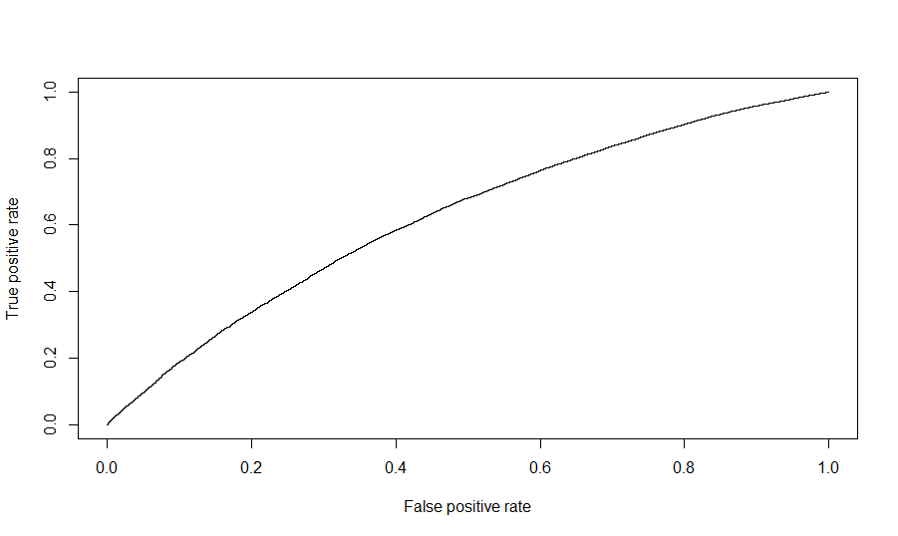

Fig.1: ROC Curve for Logistic Regression on all fields

1. Neural Network:

Results Summary:

|  |  |  |
| --- | --- | --- |
| **Train** | **Test** | **AUC** |
| 70,000 | 30,000 | 0.67 |

Architecture of the trained network:

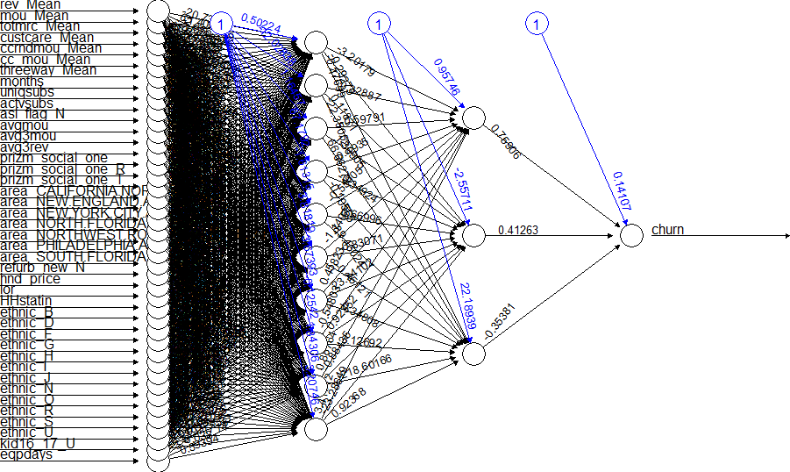

Fig.2: Architecture of the trained NN. Input layers: 42, Hidden Layer-1: 10 neurons, Hidden layer-2: 3 neurons

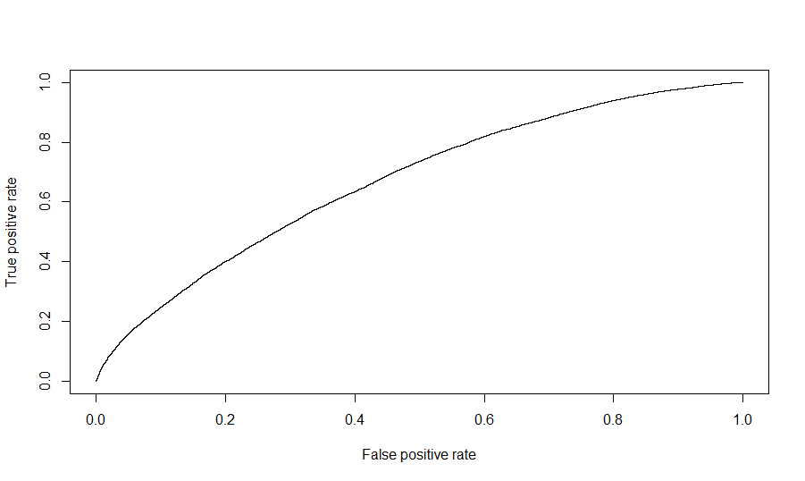

Fig.3: ROC obtained from NN prediction. AUC: 0.67

1. Random Forest Classifier:

Results Summary:

|  |  |  |
| --- | --- | --- |
| **Train** | **Test** | **AUC** |
| 70,000 | 30,000 | 0.659 |

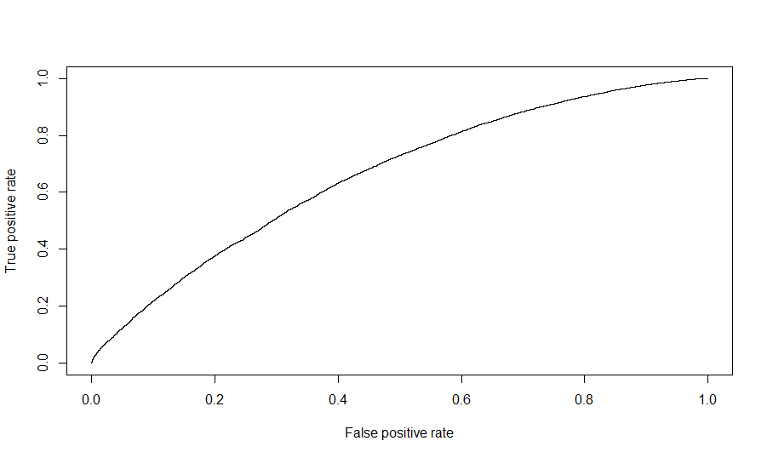

Fig.4: ROC obtained from Random Forest Classifier. AUC: 0.659